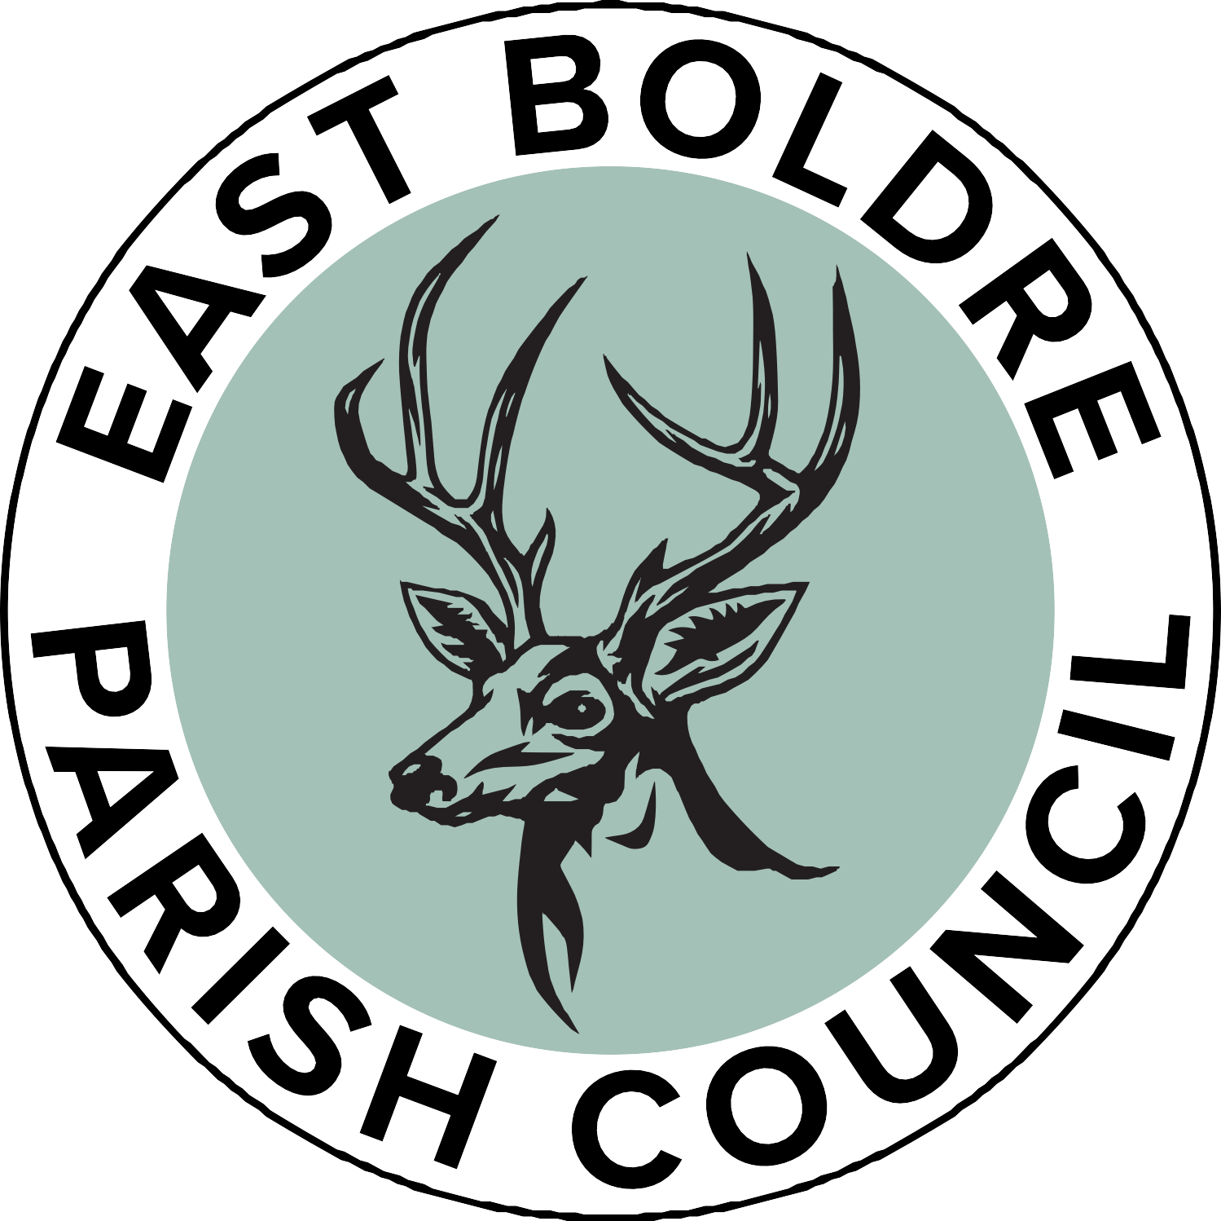

Privacy Notice

This website is run by East Boldre Parish Council. We regard your privacy as important and comply with the Data Protection Act 1998 and the General Data Protection Regulation (GDPR).
We process and hold information in order to provide public services. This notice explains how we use and share your information. Information may be collected on a paper or online form, by telephone, email or by a member of our staff, or one of our partners.

When you contact us
The information you provide (personal information such as name, address, email address, phone number, organization) will be processed and stored to enable us to contact you and respond to your correspondence, provide information and/or access our facilities and services.

The Parish Council’s right to process information
We are permitted to process information under GDPR Article 6 (1) (a) (b) and (e) when:
- Processing is with consent of the data subject or
- Processing is necessary for compliance with a legal obligation or
- Processing is necessary for the performance of a task carried out in the public interest or in the exercise of official authority vested in the controller.

Information security
East Boldre Parish Council cares to ensure the security of personal data. We make sure that your information is protected from unauthorised access, loss, manipulation, falsification, destruction or unauthorised disclosure. This is done through appropriate technical measures and appropriate policies. Copies of these policies can be requested.

Children
We will not process any data relating to a child (under 13) without the express parental/ guardian consent of the child concerned.

Access to information
You have the right to request access to the information we have on you. You can do this by contacting the Parish Clerk at clerk@eastboldre-pc.gov.uk

Information correction
If you believe that the information we have about you is incorrect, you may contact us so that we can update it and keep your data accurate. Please contact the Parish Clerk to request this: clerk@eastboldre-pc.gov.uk

Information deletion
If you wish East Boldre Parish Council to delete the information about you please contact: clerk@eastboldre-pc.gov.uk

Right to object
If you believe that your data is not being processed for the purpose it has been collected for, you may object. Please contact clerk@eastboldre-pc.gov.uk

Rights related to automated decision making and profiling
East Boldre Parish Council does not use automated decision making or profiling of individual personal data.
Conclusion
In accordance with the law, we only collect a limited amount of information about you that is necessary for correspondence, information and service provision. We do not use profiling, we do not sell your data, we do not pass your data to third parties without your consent. We do not use your data for purposes other than those specified. We make sure your data is stored securely. We delete all information deemed to be no longer necessary. We constantly review our privacy policies to keep it up to date in protecting your data.

Complaints
If you have a complaint regarding the way your personal data has been processed you may make a complaint to the Clerk at East Boldre Parish Council: clerk@eastboldre-pc.gov.uk and the Information Commissioners Office casework@ico.org.uk Tel: 0303 123 1113.

East Boldre Parish Council
PO Box 389
Brockenhurst
SO41 1BG
Tel 07562 985631
Email clerk@eastboldre-pc.gov.uk

July 2023

